Practical no. 3
Name :- Danish Altaf Solkar Enrolment no. :-24111590805
Class :- CO3K – B Subject :- OOP
Aim :- To find the area of rectangle by casting double data into float and int type.
Program :-
#include<iostream.h>
#include<conio.h>
void main()
{
double l=24.56;
double b=56.24;
double area=l*b;
clrscr();
cout<<"Area in double:- "<<area;
//to float
float areaf=(float)area;
cout<<"\nArea in float:- "<<areaf;
//to int
int areai=(int)area;
cout<<"\nArea in int:- "<<areai;
getch();
}

OUTPUT:-
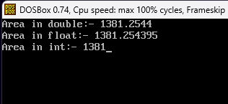

Aim :- To show use of implicit type casting to calculate the average of two numbers.
Program :-
#include<iostream.h>
#include<conio.h>
void main()
{
int num1,num2;
clrscr();
cout<<"Enter value of num 1:- ";
cin>>num1;
cout<<"Enter value of num 2:- ";
cin>>num2;
float avg=(float)(num1+num2)/2;
cout<<"Average of num1 and num2:- "<<avg;
getch();
}
OUTPUT:-
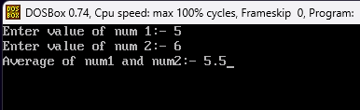

Aim :- To display the percentage of students which accept marks of three subjects from user.
Program :-
#include<iostream.h>
#include<conio.h>
void main()
{
int m1,m2,m3;
clrscr();
cout<<"Enter marks of 1st subject:- ";
cin>>m1;
cout<<"Enter marks of 2nd subject:- ";
cin>>m2;
cout<<"Enter marks of 3rd subject:- ";
cin>>m3;
float per=(float)(m1+m2+m3)/300*100;
cout<<"Your percentage of 3 subject:- "<<per;
getch();
}
OUTPUT:-
